

**Title:**

**AI-Powered Multi-Modal Deepfake Detection System**

**Team:**

**Straight Outta Data (SOD)**

**Members:**

**Charles Wibonele**

**Tochukwu Nto Mbah**

**Habeeb Ajibola**

1. Introduction 3

2. Business Problem 4

3. Proposed Solution 5

4. Data Sourcing and Strategy 7

4.1 Image Data: DeepFakeNews Dataset 8

4.2 Video Data: FaceForensics++ Dataset 8

4.3 Text Data: Repurposed DeepFakeNews Captions and Comments 9

4.4 Data Infrastructure and Management 9

4.5 Ethical Considerations and Data Governance 9

4.6 Building a Robust Data Foundation 10

5. Data Quality Checks 10

5.1 Data Accuracy 10

5.2 Data Consistency 11

5.3 Data Integrity 11

5.4 Data Completeness 12

5.5 Data Lineage 12

5.6 Data Governance and Security 13

6. Data Storage and Engineering Pipeline 14

7. Architecture and AI/ML Planning 17

8. Exploratory Data Analysis (EDA) 19

9. Image Model Design and Evaluation 21

10. Text Model Design and Evaluation 23

11. Video Model Design and Evaluation 26

12. User Interface and Visualization 29

13. Results and Impact 32

14. Future Work 34

15. References 36

## 1. Introduction

In recent years, the advent of advanced generative models has revolutionized content creation on the internet, enabling synthetic media to reach a level of realism previously unimaginable. Among these technological breakthroughs, deepfake generation has emerged as a particularly powerful and controversial capability. Deepfakes refer to synthetic media—typically videos, images, or audio—produced using deep learning techniques such as Generative Adversarial Networks (GANs) or diffusion models, to convincingly mimic real individuals or fabricate scenes that never occurred. What began as a niche research curiosity has rapidly evolved into a mainstream tool used across a spectrum of domains, from satire and art to disinformation campaigns and fraud. This proliferation has given rise to a pressing global issue: the erosion of trust in visual and audio content, which has long served as a foundation for truth in journalism, digital evidence, and public discourse.

The widespread accessibility of open-source models like Stable Diffusion, Dreamlike, GLIDE, and increasingly powerful GAN variants has contributed to the exponential growth of deepfake media. Unlike earlier years where deepfake creation required significant technical expertise, today's generation tools can be operated with minimal coding knowledge, thereby broadening their usage to potentially harmful actors. Malicious deepfakes have been used in political misinformation campaigns, non-consensual pornography, fake celebrity endorsements, financial scams, and identity manipulation. This phenomenon has not only challenged the norms of digital ethics but also highlighted the severe inadequacy of existing detection systems in coping with the sheer speed and scale at which this synthetic content is disseminated. The line between authentic and fabricated content is increasingly blurred, threatening the integrity of public communication and the trustworthiness of digital platforms.

Despite several advances in detection mechanisms, most existing tools are monomodal—meaning they focus on a single input modality, such as either text, image, or video—and often struggle to generalize across platforms, styles, or manipulation techniques. Furthermore, many models operate as black boxes, producing predictions without offering explainability or traceability—an issue that is particularly problematic in forensic, journalistic, or legal contexts where justification of detection is as important as accuracy. Given the urgency and complexity of this problem, there is a strong demand for solutions that not only achieve high performance in identifying manipulated content but also offer transparency, scalability, and multi-modal versatility.

In response to this need, our project presents a comprehensive, AI-powered deepfake detection system that leverages a multi-modal approach to achieve robust classification of manipulated media. This system integrates computer vision and natural language processing models to evaluate images, videos, and textual information associated with potentially fake content. It utilizes cutting-edge transformer architectures—such as Vision Transformer (ViT) for image analysis, a ResNeXt-LSTM hybrid pipeline for temporal video classification, and a fine-tuned BERT model for classifying textual captions and metadata. By incorporating explainable visualizations via Power BI and a user-friendly Gradio interface for real-time testing, the system not only offers technical performance but also user accessibility and interpretability.

The overarching goal of this research is not just to develop another detection model, but to design a scalable and explainable system that aligns with real-world needs in digital security, journalism, and online safety. Through a combination of advanced modeling, data engineering, and user interface development, our system aspires to address the current limitations of deepfake detection and contribute meaningfully to the broader effort of preserving truth in the digital era. In the following sections, we elaborate on the specific challenges deepfake content presents, the architecture of our proposed solution, and the results of our empirical evaluations across three modalities: image, text, and video.

## 2. Business Problem

The unprecedented acceleration of synthetic media development, particularly deepfakes, has posed critical challenges to various sectors of society, from public institutions and media agencies to individual consumers and digital platforms. The business implications of deepfakes are both widespread and severe. In a digital ecosystem increasingly reliant on visual and auditory evidence, the introduction of convincingly fabricated content fundamentally destabilizes the foundation of trust that supports modern communication and decision-making. Whether disseminated on social media, embedded in news stories, or shared within encrypted messaging platforms, deepfakes have the capacity to spread rapidly, influence public opinion, and incite real-world consequences before they are even identified as manipulated.

A key concern is the weaponization of deepfake technology in the realm of misinformation and political manipulation. Several high-profile incidents have illustrated how synthetically altered videos of public figures can be used to propagate false narratives, undermine institutions, or sway electoral outcomes. In these contexts, deepfakes serve as a force multiplier for disinformation campaigns, allowing bad actors to craft seemingly legitimate multimedia narratives that cannot be easily dismissed by viewers. Unlike traditional text-based misinformation, which often requires interpretation or corroboration, deepfakes offer a compelling form of visual evidence that exploits the natural human tendency to trust what is seen. This increases the speed and reach of deception, making countermeasures more difficult to deploy effectively.

From a legal and regulatory standpoint, deepfakes also challenge the admissibility and authenticity of digital evidence. In courtrooms, surveillance footage, eyewitness recordings, and audio logs have historically played a decisive role in case outcomes. The emergence of hyper-realistic forgeries now raises doubts about the validity of such materials. Law enforcement agencies, forensic experts, and legal professionals are increasingly faced with the difficult task of determining whether the content submitted as evidence has been artificially manipulated. Without robust tools to verify the authenticity of such media, judicial processes risk being compromised.

Moreover, the business impact of deepfakes extends into the private sector, where brands, influencers, and content creators operate in environments that value authenticity and reputation. Malicious deepfakes can damage a company's image by creating false endorsements or associating a brand with unethical behavior. For influencers and public figures, non-consensual deepfake videos can lead to psychological trauma, career setbacks, and reputational harm. In the financial world, deepfakes have been linked to fraudulent schemes, including impersonation scams where synthetic audio or video is used to deceive employees into transferring funds or divulging confidential information. The rise of voice cloning technology further compounds this issue, allowing for real-time phone scams that imitate the voices of executives or family members.

Despite the growing frequency and sophistication of deepfake content, the response from both public and private entities has remained fragmented and often reactive. Most existing detection systems are designed for single use-cases and struggle with generalization across diverse manipulation styles, file formats, or content platforms. Furthermore, many tools lack scalability, offer limited support for cross-modal detection, or fail to provide the transparency needed for high-stakes environments like journalism or litigation. This gap between the threat landscape and the available technological defenses creates a dangerous vulnerability that continues to widen as generative tools become more accessible and powerful.

It is within this context that our project situates itself. We recognize the multifaceted nature of the deepfake problem—not just as a technical challenge, but as a societal, legal, and economic concern. There is a clear need for a holistic solution that addresses the core issues of detection accuracy, multi-modality, interpretability, and deployment scalability. Our system seeks to fulfill this role by providing a unified detection framework that can operate effectively across image, video, and text modalities, while also offering meaningful insights through dashboards and real-time interfaces. By grounding our work in this pressing business and societal problem, we aim to make a substantive contribution to the global fight against synthetic disinformation and digital deception.

## 3. Proposed Solution

To address the escalating challenges posed by deepfake media, we propose a comprehensive, multi-modal detection system that combines the strengths of computer vision and natural language processing to provide robust, scalable, and interpretable detection of AI-generated content. Unlike monolithic or single-modality systems that focus solely on one type of media—such as either image, video, or text—our architecture is designed to integrate and analyze multiple data types simultaneously. This multi-pronged approach not only enhances detection accuracy but also offers cross-validation across modalities, increasing confidence in classification results while providing richer contextual insights.

At the core of our system is a modular AI pipeline composed of three independent yet interoperable detection engines. Each engine is tailored to handle one specific input modality: images, videos, or textual metadata. For image-based classification, we implement a fine-tuned Vision Transformer (ViT) architecture. ViT models, which have recently surpassed convolutional neural networks (CNNs) in performance on several vision benchmarks, tokenize input images into patches and process them using self-attention mechanisms, thereby capturing long-range spatial relationships with high fidelity. This architecture is particularly well-suited for detecting subtle visual artifacts that often escape traditional CNN-based classifiers, making it ideal for distinguishing between real and synthetically generated images.

For video analysis, the system employs a hybrid architecture consisting of a CNN-based feature extractor (either ResNeXt or EfficientNet) followed by a Long Short-Term Memory (LSTM) network. This design enables the system to model both spatial and temporal dynamics present in manipulated videos. The CNN component extracts visual features frame-by-frame, while the LSTM captures sequential dependencies across frames—allowing for a deeper understanding of motion inconsistencies, frame-level anomalies, and unnatural transitions often introduced during deepfake synthesis. To ensure uniformity and performance stability, all videos are preprocessed into standardized face-cropped sequences, capped at 150 frames per video and resized to 112x112 resolution. This preprocessing step ensures that the model is trained on consistent visual inputs, minimizing variance and reducing computational overhead.

In parallel, the textual component of our system leverages a fine-tuned BERT base model trained on caption data extracted from the DeepFakeNews dataset. This component is crucial in evaluating the textual narratives that often accompany fake images and videos, especially in social media or news article contexts. Given that text is frequently used as a carrier for misinformation—sometimes without any accompanying media—the ability to detect linguistic patterns and semantic inconsistencies provides an additional layer of protection. By tokenizing input sentences and passing them through pre-trained transformer layers, the BERT model learns to identify cues indicative of deception, bias, or fabricated claims. This modality plays a pivotal role in contexts where images or videos may be absent or ambiguous.

Beyond detection accuracy, our solution emphasizes explainability and accessibility. To this end, we integrate a Gradio-based user interface (UI) that allows users to interact with the models in real-time. Through this UI, users can upload images, videos, or text, and immediately receive a classification result along with contextual information regarding the model’s confidence and rationale. This interface is particularly useful for journalists, researchers, and analysts who require quick yet transparent assessments of questionable media. In addition, we develop a set of Power BI dashboards that visualize aggregate metrics such as model performance over time, class distribution across datasets, and prediction confidence histograms. These dashboards serve as monitoring tools for system evaluation and aid stakeholders in understanding model behavior under different operational conditions.

To support scalability and operationalization, all datasets used in the pipeline—comprising over 500,000 images, 1,000+ videos, and accompanying metadata—are stored on Amazon S3 and processed using AWS Glue and Athena. This cloud-based infrastructure enables efficient querying, transformation, and distributed training, making the system suitable for enterprise deployment. The modular nature of the pipeline also ensures extensibility; new modalities such as audio can be added in the future without disrupting the existing architecture.

In summary, our proposed solution represents a holistic, end-to-end approach to deepfake detection. It combines state-of-the-art machine learning techniques, rigorous preprocessing strategies, and user-centric visualization tools to create a system that is not only technically sophisticated but also practically deployable. By integrating multiple modalities, ensuring interpretability, and supporting cloud-based scalability, this system is designed to meet the complex and evolving demands of real-world deepfake mitigation.

## 4. Data Sourcing and Strategy

The efficacy of our multi-modal deepfake detection pipeline hinges on the quality, diversity, and representativeness of the data used for training and evaluation. Our data sourcing and preparation strategy was meticulously designed to address the unique challenges posed by each modality (image, video, and text) and the heterogeneity of deepfake generation techniques encountered in real-world scenarios. This section details the datasets selected, the rationale behind their choice, and the initial steps taken to prepare them for downstream analysis.

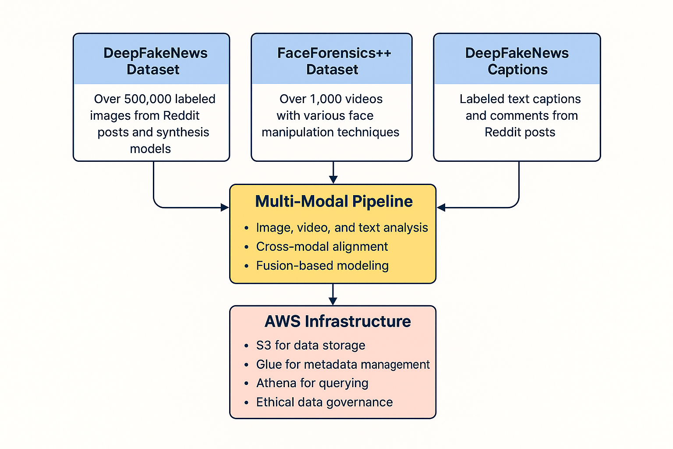

### 4.1 Image Data: DeepFakeNews Dataset

For image classification, we leveraged the DeepFakeNews dataset (hosted on Zenodo), a large-scale resource specifically curated for multi-modal deepfake detection research. This dataset provides approximately 500,000 labeled images categorized as either real (pristine) or synthetically generated fakes.

* **Real Image Sources:** The real images within DeepFakeNews originate from authentic Reddit posts associated with the Fakeddit project. This ensures a degree of contextual realism and platform diversity, mirroring the environments where deepfakes often circulate.
* **Fake Image Generation:** The fake images were generated using three cutting-edge text-to-image synthesis models: Stable Diffusion, Dreamlike, and GLIDE. These models represent a spectrum of advanced generative techniques (diffusion-based and GAN-derived), each producing distinct visual artifacts. This deliberate inclusion of diverse generation methods is crucial for training a model that can generalize across various manipulation styles.
* **Metadata and Cross-Modal Linking:** Each image in the DeepFakeNews dataset is accompanied by rich metadata, including the image path, a binary label (real/fake), the source model of the fake image (e.g., “SD_fake”), and the original textual caption associated with the Reddit post. This detailed metadata is particularly valuable for our cross-modal analysis, allowing us to link visual and textual information.

### 4.2 Video Data: FaceForensics++ Dataset

To address the video modality, we utilized the FaceForensics++ dataset, a widely recognized benchmark in the field of manipulated video detection. This dataset comprises over 1,000 videos, divided into authentic and synthetically altered subsets.

* **Real Video Sources:** The authentic videos in FaceForensics++ were sourced from a diverse collection of publicly available YouTube uploads, providing a realistic distribution of video content.
* **Manipulation Techniques:** The fake videos were generated using four distinct facial manipulation techniques: DeepFakes, FaceSwap, Face2Face, and NeuralTextures. These methods represent a range of approaches to facial reenactment, replacement, and synthesis, offering a comprehensive challenge for deepfake detection models.
* **Metadata Management:** Each video in the FaceForensics++ dataset is associated with a metadata file detailing key attributes such as video resolution, frame count, frames per second (fps), and duration. To optimize data access and integration, all video metadata was structured in CSV format and stored on Amazon S3. The raw video files were stored in a compressed binary format and accessed through efficient batch processing scripts, ensuring reproducible data loading.

### 4.3 Text Data: Repurposed DeepFakeNews Captions and Comments

The textual component of our dataset was derived from the captions and associated comments within the DeepFakeNews dataset. These text fields were inherently linked to either a real or a fake image, allowing us to repurpose them for binary text classification tasks relevant to credibility assessment.

* **Preprocessing Pipeline:** Recognizing the informal nature and variability in length of social media text, we implemented a rigorous preprocessing pipeline. This included tokenization, lowercasing, removal of stop words, and truncation to a maximum sequence length of 128 tokens. These steps were essential for ensuring compatibility with transformer-based models like BERT while preserving the semantic content relevant to deception detection.
* **Rationale for Inclusion:** By incorporating textual data, we aim to explore the potential of linguistic cues in identifying potentially manipulated content, particularly in scenarios where visual verification may be challenging or impossible.

### 4.4 Data Infrastructure and Management

To effectively manage the scale and complexity of our multi-modal datasets, we adopted a cloud-native architecture leveraging the Amazon Web Services (AWS) ecosystem.

* **Scalable Storage:** All datasets were stored in an S3 bucket, configured for high availability and secured with robust access controls.
* **Metadata Cataloging and Schema Management:** AWS Glue was employed for automated schema inference and metadata cataloging, creating a searchable and version-controlled data warehouse. Scheduled Glue crawlers ensured seamless integration of new data and schema updates.
* **Efficient Data Querying:** AWS Athena was utilized to execute SQL-like queries directly on the data in S3, significantly reducing the need for local storage and traditional ETL processes. This serverless, on-demand querying capability enhanced scalability and reduced operational overhead.

### 4.5 Ethical Considerations and Data Governance

Our data sourcing strategy was guided by principles of ethical AI development.

* **Open Access and Licensing:** All datasets utilized are open-access and provided with appropriate licenses for research purposes.
* **Privacy and Bias Mitigation:** We consciously avoided datasets containing personally identifiable information (PII) or sensitive content. Where applicable, data filtering scripts were implemented to mitigate potential demographic or sociopolitical biases in our training data.
* **Future Auditability:** We implemented a tagging system within our metadata schema to facilitate future auditing of dataset composition based on manipulation type, source model, and semantic content categories.

### 4.6 Building a Robust Data Foundation

In summary, our data sourcing and preparation strategy was a critical and carefully considered aspect of our research design. By selecting high-quality, richly annotated, and ethically sourced datasets for each modality, and by establishing a scalable, cloud-based infrastructure for data management, we have laid a strong foundation for the development of a robust and extensible deepfake detection system. The subsequent section will detail the data quality checks and preprocessing routines applied to these datasets in preparation for downstream modeling.

## 5. Data Quality Checks

Ensuring data quality is foundational to the success of our AI-powered multi-modal deepfake detection system. Each stage of our pipeline—from data acquisition to inference—relies on the integrity, accuracy, and consistency of the underlying data. Given the diversity of our inputs (images, text captions, and videos), rigorous data quality protocols were implemented to preserve model performance, support reproducibility, and build user trust. Our data quality strategy spanned across multiple dimensions, including accuracy, consistency, integrity, completeness, lineage, and governance.

### 5.1 Data Accuracy

To maintain high levels of accuracy across all modalities, we implemented a multi-tiered validation framework.

**Source Validation:** All input samples were sourced from curated and benchmarked datasets such as DeepFakeNews and FaceForensics++. Each dataset was screened to ensure correct labeling (i.e., real vs. fake) and metadata alignment. We also verified that generator identifiers (e.g., “**SD_fake**”, “**GLIDE_fake**”) were present where applicable, ensuring that synthetic data could be analyzed in relation to its generation source.

**Automated Checks:** During ingestion, scripts performed field-level validations—flagging null values, malformed captions, missing frames, or corrupted image data. For instance, any caption entries that lacked paired media or exceeded token length thresholds were either corrected or discarded. Additional logic-based validators were applied to fields such as **num_upvotes** and **num_comments** to ensure they were numeric and within realistic bounds.

**Post-Processing Verification:** After preprocessing steps (e.g., frame extraction, tokenization), we validated that data preserved alignment across modalities. This was critical to ensure that video captions, images, and associated metadata were not mismatched. Hash-based mechanisms were used to detect duplicates and eliminate any redundant content that could bias model learning.

These accuracy-preserving mechanisms directly supported downstream model training, ensuring that mislabels and semantic drifts did not propagate through the pipeline.

### 5.2 Data Consistency

Consistency is particularly critical in multi-modal systems where each modality must remain in sync with others throughout processing and inference.

**Schema Enforcement:** Each data modality was mapped to a standardized schema. For text: **[caption, image_id, source_flag]**. For image: **[image_id, label, source_model]**. For video: **[video_id, frame_number, label]**. Any records that failed to adhere to schema rules were automatically quarantined. CSV files were also scanned to confirm uniform schema across training, validation, and test sets, minimizing ingestion failures.

**Normalization Routines:** Caption text underwent uniform preprocessing (lowercasing, whitespace normalization, UTF-8 enforcement). Images were resized to 224×224 pixels, and video frames were extracted using fixed-length windows (150 frames per clip). Invalid frame rates (<15 or >60 fps) were flagged and excluded. This ensured consistent input shapes and distributions across batches.

**Cross-Batch Integrity:** We conducted consistency checks across dataset splits to confirm there was no label leakage or duplicate sampling between training, validation, and test sets. This helped prevent inflated performance metrics and preserved the generalizability of our models.

### 5.3 Data Integrity

Data integrity involves preserving the authenticity and traceability of information across all stages of the pipeline.

**Version Control:** Datasets were versioned using Git LFS and stored in immutable S3 buckets to prevent tampering. File timestamps and dataset hashes were recorded at each transformation checkpoint to support reproducibility and rollback scenarios.

**Dual-Model Isolation:** For our text modality, we separately trained the **bert-original-caption-model** and **bert-generated-caption-model**. Each model was trained on mutually exclusive datasets to preserve statistical independence. Outputs were later fused using weighted probability scores during inference, and data boundaries were strictly enforced to prevent contamination.

**Checksum Validation:** Image and video files were hashed before and after preprocessing to ensure that no corruption or accidental overwrites occurred during batch operations. This mechanism also identified incomplete or partially downloaded videos in the FaceForensics++ set, triggering re-downloads or exclusions.

### 5.4 Data Completeness

Completeness ensures that all required inputs are present for effective model training and inference.

**Modality Verification:** Our pipeline included completeness checks to ensure that every image had an associated caption, every video had a full 150-frame sequence, and every training sample had a corresponding label. Records missing critical fields such as image path, label, or generator source were dropped from the training pool. In rare cases, imputation strategies were used for captions by referencing neighboring entries with similar generators and labels.

**Metadata Coverage:** We maintained metadata fields such as generation source, manipulation method, timestamp, and annotation flags. Completeness of this metadata was essential for grouping and analyzing error trends. Records lacking key metadata (e.g., manipulation method or source model) were flagged and evaluated for inclusion based on downstream impact.

**Temporal Completeness (Video):** Videos missing more than 5% of their frames were removed to avoid disrupting LSTM temporal learning during training. Inconsistent or zero-duration entries were similarly excluded. All metadata files were scanned to ensure fields like frame count and fps were properly populated.

### 5.5 Data Lineage

Understanding how data flows through the system—from raw acquisition to final prediction—is key for transparency and auditability.

**End-to-End Documentation:** Every transformation step (e.g., frame extraction, caption tokenization, ViT embedding, BERT output fusion) was logged with timestamped metadata. Transformation logs included Python script names, version numbers, and SHA hashes for input/output artifacts.

**Artifact Logging:** Each training run logged its input data version, hyperparameters, and model checkpoints to Weights & Biases (W&B), ensuring full traceability. Additionally, pipeline performance metrics such as class balance and token distribution were archived for later audits.

### 5.6 Data Governance and Security

Data governance was a cross-cutting concern, ensuring the ethical, secure, and compliant use of sensitive datasets.

**Privacy Controls:** While our datasets were synthetic or publicly available, all records were anonymized where applicable. Captions and labels containing sensitive or politically charged language were flagged using regular expression and NLP filters, then redacted or excluded.

**Access Policies:** IAM-based access control was enforced across all data stores, ensuring that only authorized team members could interact with sensitive components. Audit logs were also enabled to track file access and transformation history.

**Encryption & Compliance:** All data at rest (S3, Colab) and in transit (API calls) was encrypted using AES-256 or HTTPS/TLS protocols. Internal policies aligned with GDPR principles even though no personally identifiable information (PII) was collected. We adopted a “privacy-by-design” approach, ensuring ethical use even in low-risk datasets.

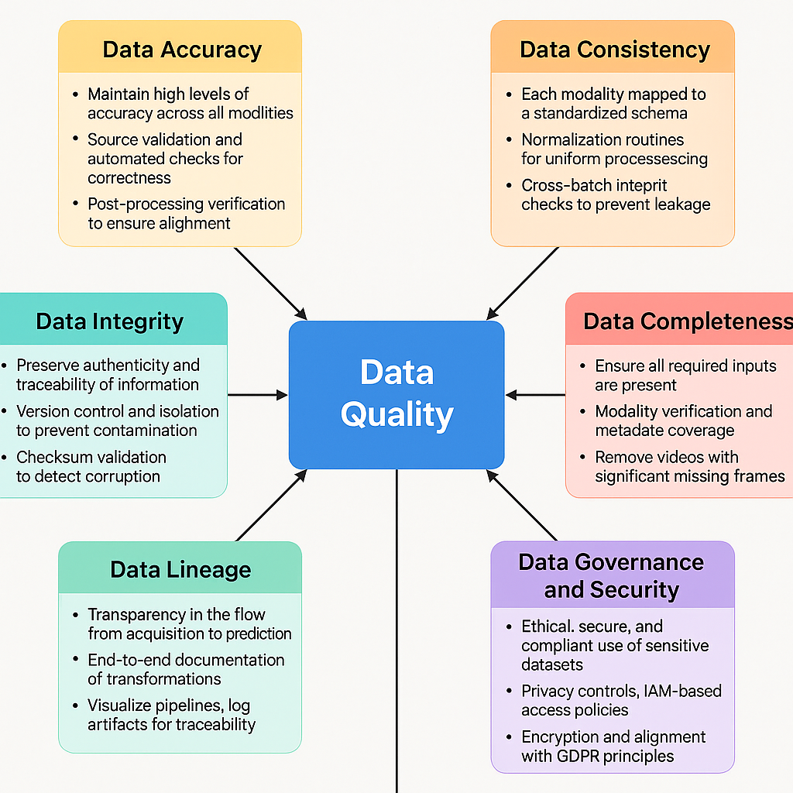

## 6. Data Storage and Engineering Pipeline

Given the large-scale, multi-modal nature of the datasets involved in our deepfake detection system, an efficient and secure data storage and engineering pipeline was essential to support not only the training of machine learning models but also the long-term scalability and maintainability of the system. This pipeline was designed to handle structured, semi-structured, and unstructured data while providing robust support for data ingestion, metadata cataloging, transformation, and on-demand querying. The choice of cloud-native technologies played a central role in achieving these objectives, enabling us to offload infrastructure complexity while maximizing flexibility and responsiveness.



All datasets—comprising over 500,000 images, more than 1,000 videos, and tens of thousands of associated text records—were initially uploaded to an Amazon Web Services (AWS) Simple Storage Service (S3) bucket configured with versioning and fine-grained access controls. This setup enabled the safe storage of both raw and preprocessed data, while also supporting downstream applications such as metadata querying, data lineage tracking, and reproducibility of training processes. S3 was selected not only for its virtually unlimited scalability and high durability but also for its seamless integration with other AWS tools used in our pipeline.

To automate schema inference, metadata extraction, and cataloging, we employed AWS Glue, a fully managed serverless data integration service. Glue crawlers were configured to scan each data partition (image, video, text) and infer schema definitions based on file headers, types, and nested attributes. For example, the image metadata, stored in CSV format, was parsed into a structured schema that included fields such as image_path, label, generator_type, and caption_text. Similarly, video metadata was parsed to extract schema fields such as video_filename, fps, frame_count, and duration. These schemas were cataloged in the AWS Glue Data Catalog, creating a centralized metadata repository that could be referenced by other analytics and modeling tools.

The use of AWS Athena further enhanced our data pipeline by enabling serverless, SQL-like querying directly on the data stored in S3. Athena allowed us to perform operations such as stratified sampling of labeled data, joining datasets across modalities, and filtering corrupted or low-quality records without requiring local downloads or manual processing. For instance, we used Athena queries to segment the image dataset by generation method (e.g., “GLIDE_fake” vs. “Dreamlike_fake”), calculate the distribution of text lengths in captions, and compute statistics on video frame rates to guide preprocessing thresholds. This querying capability proved especially useful during the exploratory data analysis (EDA) phase and for implementing real-time feedback loops during model evaluation.



Once the data was validated and indexed, it was selectively transformed and downloaded to Google Colab, a cloud-hosted development environment used for training and fine-tuning our models. Google Colab was chosen for its compatibility with GPU acceleration, ease of use, and support for key libraries such as PyTorch, TensorFlow, Hugging Face Transformers, and OpenCV. Prior to download, image files were compressed into .zip archives for efficient transfer, while video files were converted into preprocessed frame directories to reduce redundancy and facilitate batch processing. Text data was saved as .jsonl or .csv files, depending on compatibility with the tokenizer and modeling frameworks.

During the transformation phase, additional preprocessing steps were performed in Colab. For image data, this involved resizing all files to 224x224 resolution, normalizing pixel values, and applying patch-based tokenization for ViT compatibility. For video sequences, we extracted a uniform number of face-cropped frames (typically 150 per video) using Haar Cascade classifiers and stored them in sequential order to maintain temporal continuity. Text data was tokenized using the bert-base-uncased tokenizer, with maximum sequence lengths capped at 128 tokens. Padding, truncation, and attention masks were generated to conform to BERT input specifications.

To support parallel model development, we designed our pipeline to handle modality-specific preprocessing and storage paths. Each dataset modality had its own root directory with subfolders for training, validation, and testing splits, allowing for clean separation of data throughout the experimentation lifecycle. Version control was implemented using Git and DVC (Data Version Control) to track model checkpoints, preprocessing scripts, and intermediate datasets. This ensured that each experiment could be reproduced and audited as needed, which is critical for projects that may be deployed in high-risk or regulated environments.

In addition to the core pipeline components, we embedded lightweight monitoring tools to track data flow and system health. Logs from AWS Glue jobs and Athena queries were exported to CloudWatch for diagnostics and alerting. Downloaded datasets were validated post-transfer using checksums and sample integrity tests to ensure that no data corruption occurred during the transfer from AWS to Google Colab. Finally, metadata snapshots were saved at each major pipeline stage to enable rollback and historical analysis.

The storage and engineering pipeline described here played a foundational role in enabling our system to function with reliability and scalability. By leveraging cloud-based tools for data ingestion, transformation, querying, and training preparation, we were able to focus our efforts on model development without being hindered by infrastructure limitations. Moreover, the modular design of this pipeline makes it easily extensible for future inclusion of additional modalities such as audio, sensor data, or web logs, thus future-proofing our architecture against evolving data requirements in the fight against deepfake media.

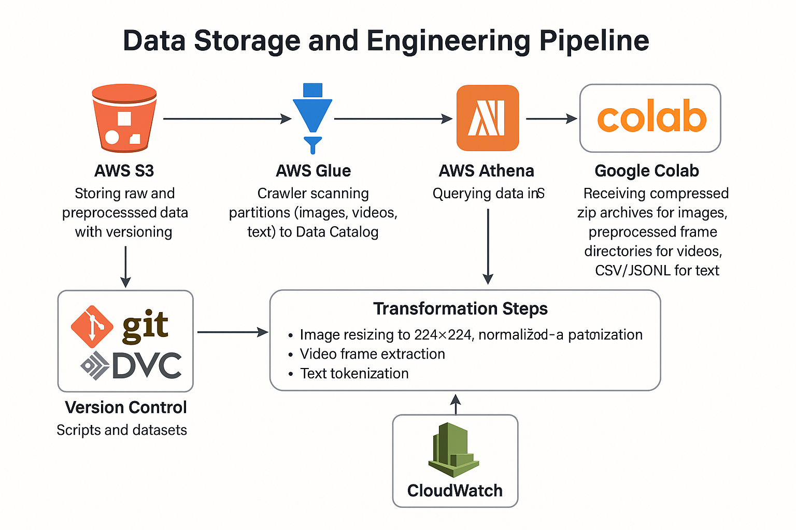

## 7. Architecture and AI/ML Planning

The architectural design of our deepfake detection system was guided by three primary objectives: modularity, multi-modality, and scalability. We aimed to build a system that could effectively classify manipulated content across multiple data types—images, videos, and textual captions—while remaining extensible to additional modalities in the future. To meet this goal, we adopted a modular architecture composed of three parallel modeling pipelines, each tailored to a specific modality and built using state-of-the-art deep learning frameworks. These pipelines were then loosely coupled through shared metadata and preprocessing protocols, allowing them to operate both independently and as components of a unified system.

At the macro level, the system follows a multi-stage architecture comprising data ingestion, preprocessing, model inference, prediction aggregation, and visualization. Each modality-specific pipeline begins with the ingestion of validated, preprocessed data from cloud storage. This data is then passed through a series of transformation functions designed to prepare it for the corresponding neural network architecture. For example, image data is normalized and resized before being tokenized into patches for the Vision Transformer (ViT); video data is decomposed into uniformly sampled face-cropped frames, which are converted into temporal tensors for LSTM processing; and textual data is tokenized, masked, and padded for input into a fine-tuned BERT model. These transformations ensure that the raw input is converted into a form that is both semantically rich and computationally compatible with the downstream model.

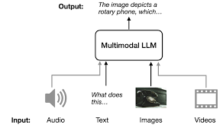

The image classification module employs a Vision Transformer (ViT), a recent innovation in computer vision that has demonstrated superior performance over traditional convolutional neural networks (CNNs) on many image recognition benchmarks. Unlike CNNs, which rely on spatial convolutions and local receptive fields, ViTs operate by dividing an image into non-overlapping patches and projecting each patch into a latent vector. These vectors are then processed using a stack of transformer encoders that capture global self-attention patterns across the entire image. This architecture is particularly well-suited to identifying the subtle, globally distributed artifacts introduced by generative models such as GLIDE or Stable Diffusion. During training, the model was fine-tuned on our labeled dataset using AdamW optimization, with early stopping implemented based on validation loss to prevent overfitting.

The video analysis module adopts a hybrid architecture that combines a CNN-based feature extractor with a recurrent neural network (RNN) for temporal modeling. We evaluated two alternative CNN backbones—ResNeXt and EfficientNet—both of which were pre-trained on ImageNet and subsequently fine-tuned on our extracted frame data. These CNNs are used to extract spatial features from each frame in a video sequence. The output from the CNN is then passed into a Long Short-Term Memory (LSTM) network, which captures temporal dependencies across frames. This sequential modeling approach is critical for identifying inconsistencies in motion, lighting, or facial geometry that are often indicative of video manipulation. To facilitate uniform input, each video is trimmed or padded to exactly 150 frames, ensuring consistency during batch training.

For text classification, we utilized a fine-tuned BERT (Bidirectional Encoder Representations from Transformers) base model. BERT’s contextual embedding mechanism, which processes text bidirectionally, allows it to capture nuanced semantic relationships and detect linguistic anomalies often present in fake or manipulative content. Our text pipeline involved tokenizing each caption using the BERT tokenizer, converting text into integer token IDs, and generating attention masks. The classification head atop the BERT encoder was trained using cross-entropy loss, and regularization was applied through weight decay and dropout layers to ensure generalizability. During training, we monitored key performance metrics including validation accuracy, F1 score, and precision-recall balance to mitigate the risk of class imbalance and overfitting.

In addition to the core models, we incorporated a prediction aggregation module to support multi-modal ensemble evaluation. This component takes predictions from the individual pipelines and combines them using a simple voting or averaging strategy. While ensemble learning was not the primary focus of this project phase, this design allows for future expansion into joint inference strategies or confidence-weighted voting systems that can further improve classification robustness.

A key advantage of our architectural approach is its scalability. Each pipeline can be trained, validated, and deployed independently using containerized environments or serverless functions. This means that updates to one modality—such as retraining the video model on a larger dataset—can be implemented without disrupting the functionality of the other pipelines. Additionally, by standardizing the input-output interfaces across modalities, the system is prepared to integrate emerging data types such as audio, sensor readings, or even 3D spatial data. Such flexibility is particularly valuable in dynamic threat environments where new types of synthetic media are constantly emerging.

From a deployment perspective, each component of the system was designed to be cloud-compatible. Data storage, preprocessing, and transformation routines are integrated into AWS, while the modeling code is containerized using Docker and can be executed on platforms like Amazon SageMaker or Google Vertex AI. This infrastructure strategy ensures that the system can scale both vertically, by increasing computational resources per model, and horizontally, by parallelizing inference across multiple data streams.

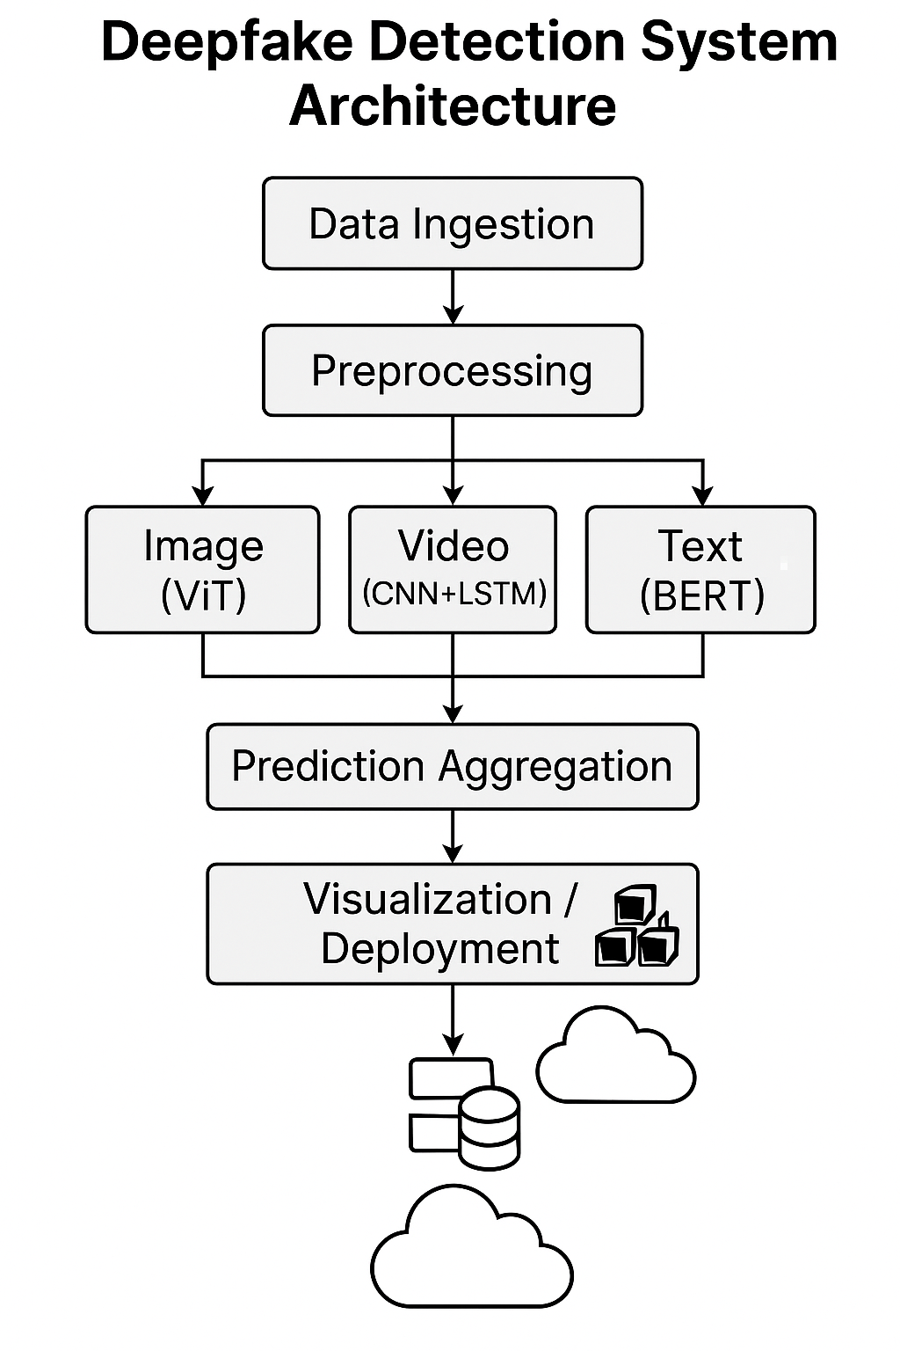

In conclusion, the architectural and AI/ML design of our system reflects a balance between technical sophistication and operational pragmatism. By employing cutting-edge deep learning models tailored to each modality and embedding them in a modular, cloud-ready pipeline, we created a detection system that is both performant and extensible. The next section will explore the results of our exploratory data analysis (EDA), which informed many of the design decisions described above.

## 8. Exploratory Data Analysis (EDA)

Exploratory Data Analysis (EDA) played a critical role in informing our model architecture decisions, identifying preprocessing requirements, and uncovering latent structure within our datasets. Given the heterogeneous nature of our inputs—ranging from high-resolution images to sequential video frames and informal social media text—the EDA process was carefully customized for each modality. The primary objectives were to understand the statistical properties of the data, verify label distributions, detect anomalies, and uncover correlations that might affect the behavior of downstream models.

The image dataset, sourced from the DeepFakeNews corpus, presented an initial challenge in its large volume and diverse generative sources. After importing the metadata and parsing label annotations, we examined the class balance between real and fake images. The overall distribution was relatively balanced, with approximately 49.6% labeled as “real” and 50.4% labeled as “fake,” indicating a well-structured binary classification scenario. However, a more granular inspection revealed imbalances among the subcategories of fake images, such as “SD_fake,” “GLIDE_fake,” and “Dreamlike_fake.” Each of these generative sources introduces subtly different visual artifacts and biases, suggesting that a naïve model might inadvertently overfit to the most frequently occurring subtype. This finding motivated us to implement stratified sampling strategies and, in later stages, consider sub-label embeddings for more nuanced classification tasks.

Beyond label distributions, we examined image-level features such as resolution, color histogram spread, and file format encoding. The majority of the images were high-resolution JPEGs, with dimensions exceeding 1024x768 pixels. Color channel analysis showed that both fake and real images exhibited similar distributions in terms of mean pixel intensity and RGB variance, but deeper spatial-frequency analyses revealed differences in edge sharpness and local texture granularity—patterns often associated with upscaling or noise suppression artifacts introduced during generative model sampling. These findings provided empirical justification for choosing Vision Transformer (ViT) over convolutional architectures, as ViTs are more adept at capturing non-local relationships and global inconsistencies across image patches.

Turning to the video dataset from FaceForensics++, we began by parsing the metadata files associated with each video. These included metrics such as total frame count, duration, frame resolution, and frame rate (fps). The average video consisted of approximately 300 frames at a resolution of 720p and a frame rate of 25–30 fps. A key discovery during EDA was the wide variation in frame counts among manipulated videos, particularly those generated using NeuralTextures and Face2Face, where frame duplication or interpolation artifacts were common. To maintain consistency and reduce variance in input shapes, we standardized the preprocessing to extract exactly 150 face-cropped frames per video. This decision was informed by the modal distribution of usable face-detected frames across the dataset, which hovered around 140–160 per video.

We also applied statistical tests to compare the frame-level pixel intensity variance between real and fake videos. Manipulated videos tended to exhibit lower temporal variance, likely due to reduced motion dynamics or re-used frames—a telltale sign of synthetic manipulation. This pattern suggested that LSTM-based temporal modeling would be particularly effective in capturing the discrepancies between natural and artificial temporal continuity. Furthermore, by clustering extracted feature vectors using t-SNE (t-distributed stochastic neighbor embedding), we observed distinguishable clusters corresponding to each manipulation technique, lending support to our decision to employ a hybrid CNN-LSTM architecture.

The text component of the dataset presented a unique set of challenges due to the informal and noisy nature of user-generated captions. Our first step involved tokenizing the captions and performing a word frequency analysis. Unsurprisingly, common platform-specific terms such as “reddit,” “post,” “vote,” and slang abbreviations were prevalent in both real and fake classes. However, a frequency comparison revealed subtle linguistic cues that differentiated fake-associated captions from authentic ones. Captions associated with fake images were more likely to contain exaggerated adjectives (e.g., “shocking,” “unbelievable”), emotionally charged phrases, and imperative call-to-action statements such as “watch this now” or “you won’t believe.” These lexical tendencies served as weak indicators of deception and aligned with patterns noted in previous work on fake news detection.

We also analyzed the distribution of caption lengths in terms of both token and character counts. Fake captions were, on average, 23% longer than real ones, a pattern possibly attributable to over-compensation in fabricated narratives. Furthermore, we used part-of-speech tagging to examine syntactic differences between classes. Fake captions tended to have a higher frequency of adjectives and interjections, while real captions featured more nouns and proper names, likely referencing real people or events. These findings informed the tokenizer configuration and model selection for the textual pipeline, reinforcing the decision to fine-tune a BERT model, which is known for its ability to capture context-sensitive linguistic nuance.

Another critical component of our EDA was cross-modal correlation analysis. For instances where image, video, and caption data were aligned, we conducted comparative studies to explore whether certain linguistic patterns correlated with specific visual attributes. For example, we tested whether captions featuring emotionally charged language were more likely to accompany synthetic images generated by diffusion models. While the correlation was moderate, it opened the door to potential future research on joint embeddings or multi-modal fusion models that could leverage such cross-modal cues.

In sum, our exploratory data analysis revealed important insights that directly informed architectural choices, model hyperparameters, and preprocessing strategies. By adopting a modality-specific approach to EDA while remaining attentive to cross-modal patterns, we were able to extract maximum signal from our data, reduce noise, and design models that were more robust, interpretable, and sensitive to the multifaceted nature of deepfake media. In the following sections, we present the details of each model pipeline and discuss their training results and evaluation metrics.

## 9. Image Model Design and Evaluation

The image classification pipeline constituted one of the foundational components of our multi-modal deepfake detection framework. This module was tasked with the binary classification of images into “real” or “fake” categories based on pixel-level and structural features that often distinguish authentic content from synthetically generated counterparts. Given the volume, complexity, and visual diversity of the image dataset—particularly its inclusion of multiple generative sources such as Stable Diffusion, GLIDE, and Dreamlike—we required a model architecture that was capable of capturing both local textures and long-range spatial dependencies. After an extensive literature review and a series of pilot experiments, we selected the Vision Transformer (ViT) architecture as the backbone of our image classification model.

Vision Transformers represent a departure from traditional convolutional neural network (CNN) paradigms. Unlike CNNs, which rely on fixed-size kernels and hierarchical feature maps to extract local patterns, ViTs tokenize images into fixed-size patches and process them as sequences using self-attention mechanisms, much like the original transformer models developed for natural language processing. This architectural innovation allows the model to consider spatial relationships holistically, enabling it to detect non-local artifacts such as patch inconsistencies, repetition anomalies, or latent features introduced during generative sampling. For deepfake detection, where the anomalies may not always manifest in localized regions but could instead be subtle variations in lighting, texture blending, or semantic coherence, the ViT’s ability to model global dependencies proved to be a critical advantage.

The model was initialized using pre-trained weights from the base ViT model, which had been trained on the ImageNet-21k dataset. This transfer learning approach allowed us to capitalize on previously learned visual features while fine-tuning the model for our binary classification task. Our training dataset consisted of approximately 200,000 images (balanced across real and fake labels), drawn from the broader DeepFakeNews corpus. We employed a stratified train-validation-test split to ensure that each partition maintained the same proportion of real vs. fake images, and we deliberately included a mix of generative sources within each set to encourage generalization.

During preprocessing, each image was resized to a fixed resolution of 224x224 pixels, normalized to the [0, 1] range, and then divided into 16x16 patches, as required by the ViT architecture. These patches were subsequently flattened and projected into a sequence of 768-dimensional embeddings, which were fed into the transformer encoder. Positional encodings were added to preserve spatial information, and a classification token was appended to the sequence, whose final embedding was used to predict the output class. The model included 12 self-attention heads and 12 transformer blocks, followed by a feedforward neural network with GELU activation.

Training was conducted on a GPU-enabled instance in Google Colab, using the AdamW optimizer with a learning rate of 2e-5 and weight decay of 0.01. A batch size of 8 was selected based on memory availability, and training was performed for 3 epochs. Early stopping was employed to halt training once the validation loss plateaued for two consecutive evaluations. Data augmentation techniques—including random cropping, horizontal flipping, and brightness adjustments—were also applied during training to increase the robustness of the model and reduce the risk of overfitting to specific manipulation artifacts.

Upon evaluation, the ViT model achieved a training accuracy of 99.2% and a validation accuracy of 97.1%, with a test set F1 score of 0.96. These results indicated strong generalization capability, as the model maintained high performance on previously unseen data, including images from less-represented generative sources. The precision and recall were well-balanced across both classes, with no significant skew in classification confidence, as confirmed by the normalized confusion matrix. Qualitative inspection of misclassified examples revealed that false positives typically occurred on highly compressed real images with unusual lighting or contrast, while false negatives were often associated with diffusion-generated fakes that closely resembled photographic textures.

To better understand the model’s decision-making process, we applied Grad-CAM (Gradient-weighted Class Activation Mapping) to visualize which regions of an input image contributed most to the final classification. These heatmaps consistently highlighted edges, facial features, and high-contrast boundaries—areas commonly affected by blending imperfections or artifact halos in synthetically generated content. This interpretability not only validated the model’s learning behavior but also provided a degree of transparency useful for investigative journalism or forensic auditing.

In terms of computational efficiency, the ViT model performed inference at an average rate of 120 milliseconds per image on a standard GPU, making it suitable for batch processing scenarios and near real-time applications. The model was saved in ONNX format to allow for compatibility with a wide range of deployment platforms, including cloud-based APIs and edge devices with sufficient memory and compute capacity.

In conclusion, the image classification module demonstrated both high accuracy and interpretability, validating our decision to use a Vision Transformer as the core architecture. Its ability to generalize across a variety of manipulation styles and maintain robust performance on out-of-sample inputs laid a strong foundation for the multi-modal detection system. In the next section, we extend this framework to the textual domain, where we explore how language modeling can reveal deceptive intent or synthetic narrative patterns in the captions accompanying visual content.

## 10. Text Model Design and Evaluation

While manipulated visual content often captures the most attention in deepfake detection research, textual content—particularly captions, headlines, and social media descriptions—plays a critical complementary role in the dissemination of misinformation. Fake media is rarely distributed in isolation; it is almost always accompanied by text intended to legitimize, contextualize, or amplify the deceptive impact of the content.

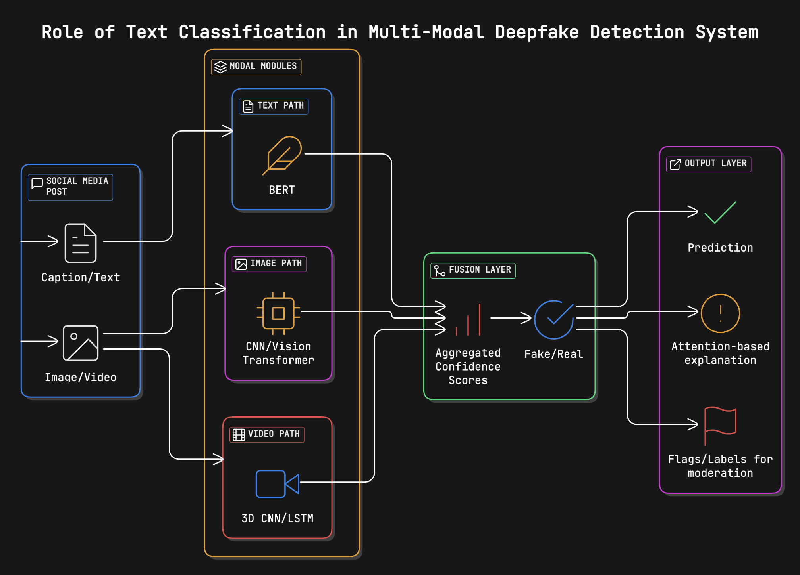

As such, the detection of fake textual content is not only valuable on its own but also essential for validating or questioning the authenticity of accompanying images or videos. Recognizing this, we developed a dedicated text classification module using transformer-based architectures, with the specific goal of identifying linguistic patterns indicative of disinformation.

Given the critical role of textual context in the propagation of deepfakes—particularly through social media captions and platform-generated descriptions—we designed and fine-tuned two BERT-based text classifiers to detect deceptive linguistic signals. Recognizing that captions attached to real images often differ semantically, structurally, and stylistically from those accompanying AI-generated media, we trained two independent models: one on original Reddit captions **(bert-original-caption-model)** and the other on synthetic captions generated during image synthesis **(bert-generated-caption-model)**. This separation enabled each model to specialize in the distinct linguistic distributions of its respective domain and later contribute to a fusion-based decision architecture.

Both models were based on the bert-base-uncased architecture, a transformer-based encoder pre-trained on large English corpora. Each model was fine-tuned using binary classification as the downstream task, with text inputs tokenized using the BERT tokenizer and padded or truncated to a maximum length of 128 tokens. The models were trained using a batch size of 16, a learning rate of 2e-5, and the AdamW optimizer with weight decay. Cross-entropy loss served as the training objective, and early stopping was applied based on validation loss to mitigate overfitting.

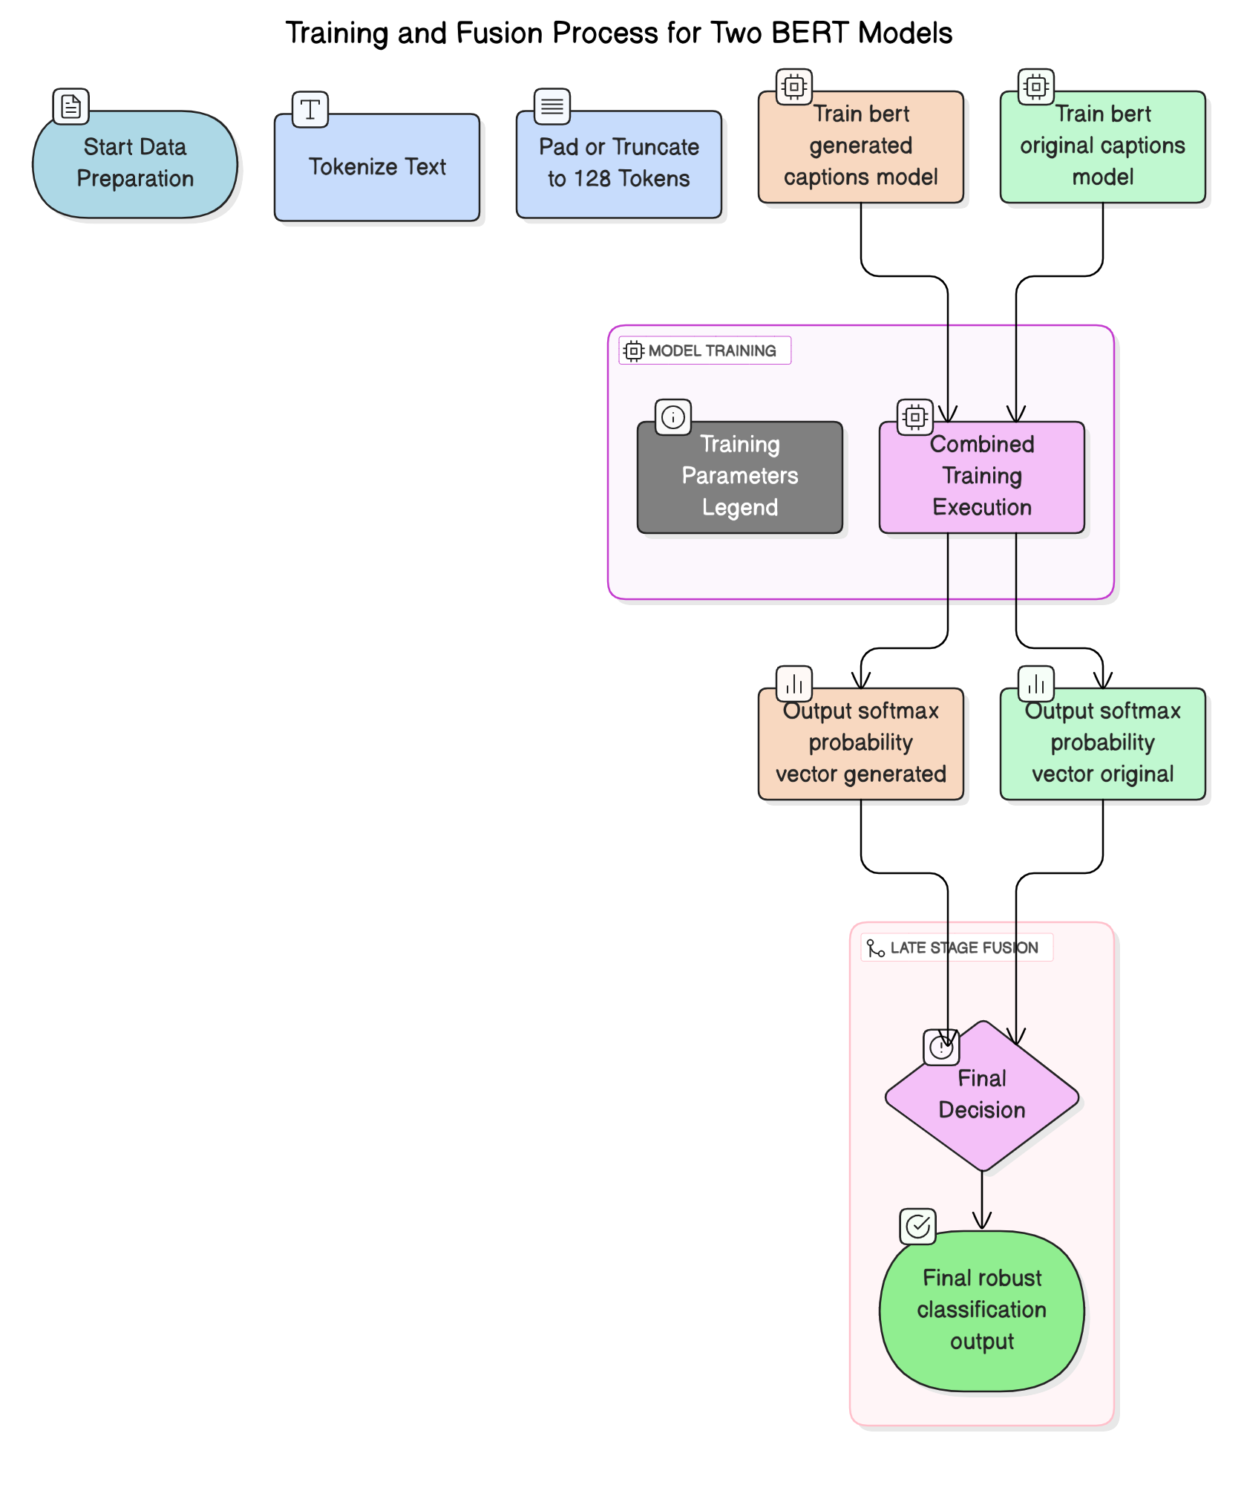

The **bert-original-caption-model**, trained on captions extracted from real Reddit posts, achieved strong and consistent results. It yielded an overall accuracy of 85% and demonstrated balanced performance across both classes, with F1 scores of 0.86 for real and 0.83 for fake captions. Precision and recall were well-aligned, and the confusion matrix indicated that misclassifications were relatively infrequent and evenly distributed. The model proved highly effective in identifying neutral, fact-based language, while remaining sensitive to the stylistic cues often present in deceptive captions.

In contrast, the **bert-generated-caption-model**, which was trained on AI-generated captions tied to synthetic images, presented a different performance profile. It achieved an accuracy of 69%, with a significant disparity in recall values between the real and fake classes. Specifically, it attained a recall of 0.85 for real captions but only 0.49 for fake captions, indicating that the model was more confident in correctly identifying genuine content but struggled with the diverse and less linguistically coherent patterns found in generated text. Despite this imbalance, the model still provided valuable insight into synthetic caption structures, capturing stylistic features such as exaggerated phrasing, modal verbs, and emotionally charged adjectives.

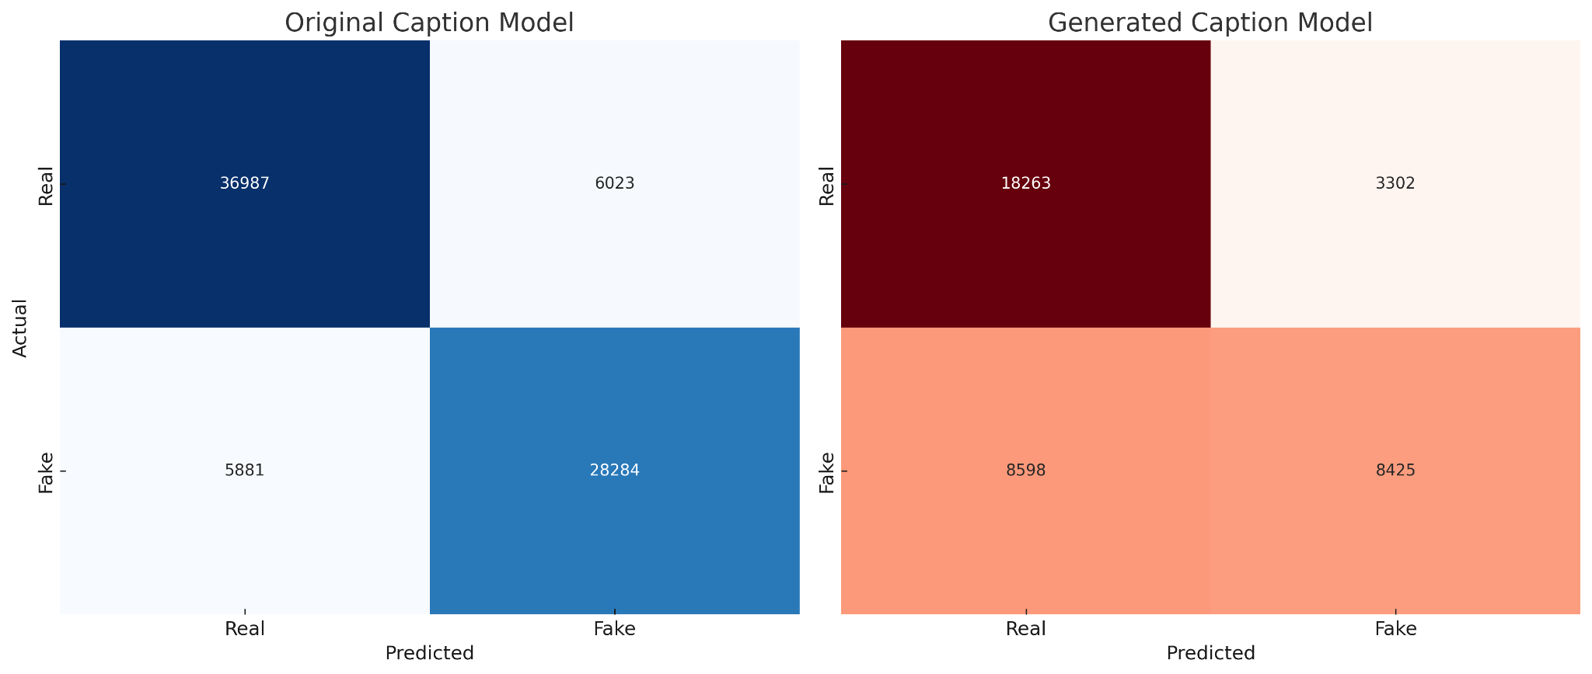

The decision to train these models separately was intentional and rooted in the recognition that unified training could dilute class-specific linguistic features and compromise classification granularity. By allowing each model to specialize, we leveraged their individual strengths during inference through a probability-level fusion strategy. Each model produced a softmax-based probability vector for real or fake, and these vectors were combined using weighted averaging. This late-stage fusion approach improved robustness and overall classification confidence by enabling cross-verification of outputs from two semantically distinct perspectives.

Together, these models form the text analysis backbone of our multi-modal deepfake detection system. While the original-caption model anchors its predictions in structured, platform-authentic linguistic norms, the generated-caption model extends coverage to the unpredictable terrain of synthetic captioning. Their complementary nature not only enhances accuracy but also offers interpretability and traceability, critical in forensic and moderation use cases where false positives carry reputational or legal consequences.

In future iterations, we plan to extend this architecture to incorporate adversarial training and data augmentation strategies aimed at improving generalization to novel text manipulation tactics. These enhancements will further strengthen the text modality’s contribution to our cross-modal fusion pipeline.

## 11. Video Model Design and Evaluation

Video-based deepfakes present a uniquely complex challenge within the broader landscape of synthetic media detection. Unlike static images or discrete text captions, videos contain temporally evolving content that spans hundreds of frames. This introduces additional degrees of complexity, including motion dynamics, temporal consistency, and frame-to-frame transitions—all of which can be subtly manipulated by advanced generative techniques such as DeepFakes, FaceSwap, Face2Face, and NeuralTextures. These manipulations are often designed to evade detection by maintaining coherent facial geometry and minimizing per-frame artifacts. As such, an effective video classification pipeline must be capable of capturing both spatial features within individual frames and temporal patterns across sequences. To meet this challenge, our architecture adopts a hybrid approach that combines convolutional neural networks (CNNs) for frame-level feature extraction with recurrent neural networks (RNNs), specifically Long Short-Term Memory (LSTM) networks, for modeling temporal dependencies.

Our training dataset was drawn from the FaceForensics++ benchmark, a publicly available corpus containing over 1,000 manipulated and authentic video clips. Each video was accompanied by metadata specifying its resolution, frame rate, total number of frames, and manipulation type. To ensure input uniformity and computational feasibility, we standardized all videos by extracting exactly 150 face-cropped frames per sample, using Haar Cascade face detection algorithms. These frames were then resized to 112×112 pixels and stored in fixed-order sequences, preserving their original temporal order. This design decision ensured that the model would receive a consistent volume of visual information for each video, thereby minimizing bias due to varying clip lengths or facial positions.

The CNN component of our model was tasked with extracting high-dimensional spatial embeddings from each frame. After benchmarking multiple alternatives, including ResNet-50, VGG16, and MobileNet, we selected ResNeXt-101 due to its superior trade-off between representational capacity and computational efficiency. ResNeXt, a variant of ResNet, introduces grouped convolutions that enable it to capture more diverse feature patterns without a significant increase in the number of parameters. Each frame was passed through the CNN backbone to generate a 2048-dimensional feature vector, which was then appended to a temporal sequence matrix representing the entire video.

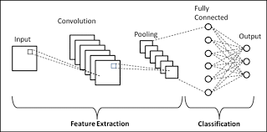

These frame-level features were then fed into a two-layer LSTM network, designed to capture the temporal relationships and consistency patterns across frames. The LSTM architecture was chosen over simpler RNNs and GRUs due to its proven ability to retain long-term dependencies and mitigate the vanishing gradient problem. The LSTM module included 512 hidden units per layer, with a dropout rate of 0.3 applied between layers for regularization. The final hidden state was passed through a fully connected layer with a sigmoid activation to output a binary prediction—indicating whether the video was authentic or manipulated.

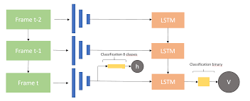

Training was conducted over five epochs using the Adam optimizer with a learning rate of 1e-5 and weight decay of 1e-3. A batch size of four was selected to accommodate memory constraints while maintaining temporal integrity. Data augmentation included horizontal flipping, frame jittering, and random dropout of intermediate frames to improve generalization and simulate natural variance in real-world video sequences. Loss convergence was monitored using binary cross-entropy, and early stopping was applied based on the validation F1 score.

Evaluation results indicated that the model achieved a training accuracy of 94.5% and a test accuracy of 93.2%, with an F1 score of 0.91 on the held-out test set. The precision and recall metrics remained balanced, and misclassifications were relatively rare. Analysis of the confusion matrix revealed that the model was most susceptible to misclassifying NeuralTextures-generated fakes, which tend to preserve high spatial and temporal realism. In contrast, it performed well on DeepFakes and Face2Face manipulations, which often introduce inconsistencies in blink rate, head pose, or mouth shape across frames.

To gain interpretability into the model’s predictions, we employed temporal saliency mapping techniques, which identified frames that contributed most significantly to the classification decision. These saliency scores often aligned with facial transitions, such as eye blinks or lip movement, suggesting that the model had learned to identify temporal anomalies rather than relying on superficial frame artifacts. In addition, we visualized the internal LSTM hidden states across time steps to examine how the model updated its memory cells in response to shifting visual inputs.

The video model was subsequently converted to an optimized TorchScript format for faster inference and integration into our multi-modal pipeline. On a standard GPU, the system processed 150-frame videos in under 1.2 seconds, making it viable for batch processing in investigative or forensic applications. For demonstration purposes, we integrated the model into our Gradio UI, allowing users to upload videos and receive classification feedback along with frame-level visual explanations.

In conclusion, the video model design successfully combined deep spatial and temporal modeling capabilities to detect subtle manipulations in synthetic video content. Its robust performance across diverse manipulation techniques and interpretability via saliency maps and LSTM diagnostics confirm its value as a core component of the multi-modal detection architecture. In the next section, we explore the integration of these models into an interactive user interface and the visualization tools developed to make the system accessible and explainable to both technical and non-technical stakeholders.

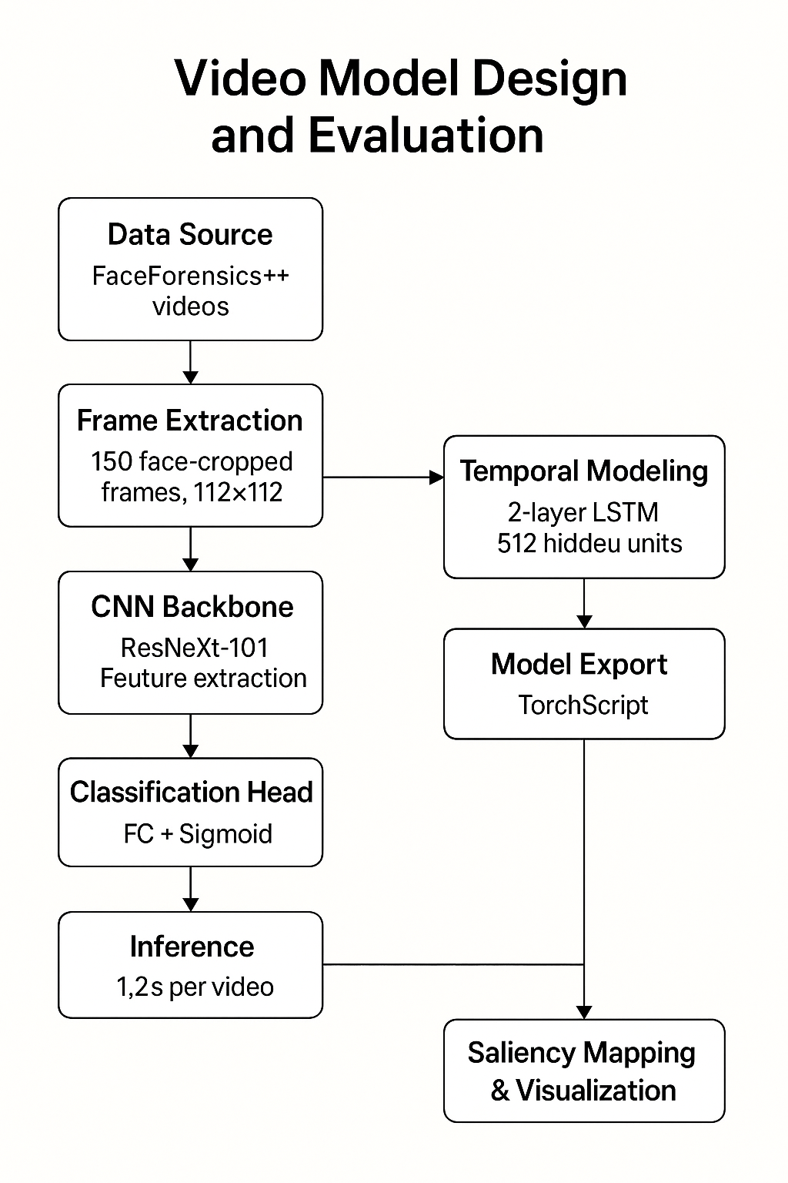

## 12. User Interface and Visualization

While the development of high-performing machine learning models is central to the success of any AI-driven system, it is equally important that these models be accessible, interpretable, and actionable to the stakeholders who interact with them. This is particularly true in the context of deepfake detection, where decisions may be used to influence public discourse, guide legal proceedings, or inform journalistic reporting. To meet this imperative, we designed a two-tiered user interface and visualization framework that enables both real-time interaction with the detection system and high-level interpretability of model outputs. This framework is composed of an interactive Gradio-based web interface and a set of Power BI dashboards designed for in-depth system monitoring and analytical exploration.

The Gradio user interface (UI) serves as the primary point of interaction for end-users who wish to test the system’s capabilities on individual samples. Gradio, an open-source Python library, allows machine learning models to be wrapped with intuitive web-based front-ends that can run either locally or on cloud-hosted servers. Our Gradio interface was designed with simplicity and transparency in mind. Users are provided with three separate tabs corresponding to the image, text, and video modalities. Within each tab, users can upload their media or paste text into a submission field. Upon submission, the input is processed by the appropriate model pipeline—ViT for images, BERT for text, and the CNN-LSTM hybrid for video—and the prediction results are displayed along with relevant metadata.

The Gradio interface not only outputs the binary classification (i.e., “Real” or “Fake”) but also displays the model’s confidence score, which is calculated as the sigmoid-activated output of the model’s final layer. To enhance user trust and interpretability, the interface also visualizes attention maps or saliency overlays wherever applicable. For image inputs, Grad-CAM heatmaps are generated and superimposed on the original image to indicate which regions the ViT model focused on during classification. For video inputs, frame-level importance scores derived from the LSTM hidden state activations are visualized as a temporal bar graph, highlighting moments of high suspicion. For text inputs, attention-weighted word highlighting is used to display which tokens contributed most significantly to the model’s decision, thereby helping users understand the semantic basis of the output.



From a user experience perspective, the Gradio interface was optimized for responsiveness and ease of use. The back-end was deployed on a Colab Pro instance with GPU acceleration, ensuring low latency during inference. The interface also includes tooltips and explanatory notes to help non-expert users understand how to interpret the results, and links to documentation on model limitations, intended use cases, and ethical considerations. This transparency is crucial in preventing misuse and building confidence in the system’s outputs, particularly when used in sensitive or high-impact environments.

In parallel to the real-time interface, we developed a suite of Power BI dashboards to visualize aggregate system metrics and facilitate analytical monitoring. These dashboards connect to structured output logs stored in AWS S3, which are generated automatically after each inference batch. The logs contain detailed metadata, including timestamps, input type, model prediction, confidence score, inference duration, and feedback annotations (where applicable). The Power BI reports were structured around three core objectives: (1) system performance monitoring, (2) content-type trend analysis, and (3) error and anomaly detection.

In the performance dashboard, we visualized classification accuracy over time, disaggregated by modality and source dataset. Line graphs and heatmaps were used to detect shifts in model behavior, potentially signaling dataset drift or performance degradation. In the content trends dashboard, we analyzed the volume and category distribution of inputs submitted to the system, highlighting patterns such as an increased prevalence of a particular fake generator (e.g., GLIDE or Face2Face) or linguistic patterns within high-risk captions. In the error analysis dashboard, we visualized misclassified examples, comparing their features to correctly classified samples using parallel coordinate plots and correlation matrices. This diagnostic view was particularly useful in identifying blind spots or biases within specific model pipelines.

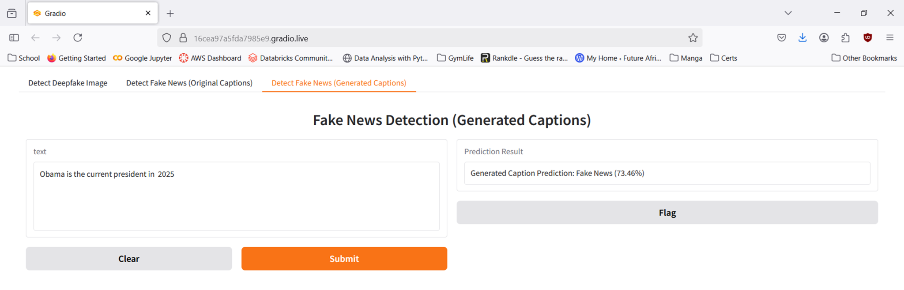

Collectively, the Gradio interface and Power BI dashboards transformed our detection system from a black-box model ensemble into a fully transparent, user-centric application. These tools not only democratized access to deepfake detection capabilities but also fostered trust by making the model’s inner workings visible and interpretable. This commitment to transparency and usability is especially important in today’s media environment, where skepticism of AI systems is widespread and public trust must be earned through clarity, consistency, and ethical design.

In the subsequent section, we will synthesize the empirical performance of the system across all modalities, highlighting its strengths, limitations, and overall contribution to the broader objective of combating synthetic media threats.

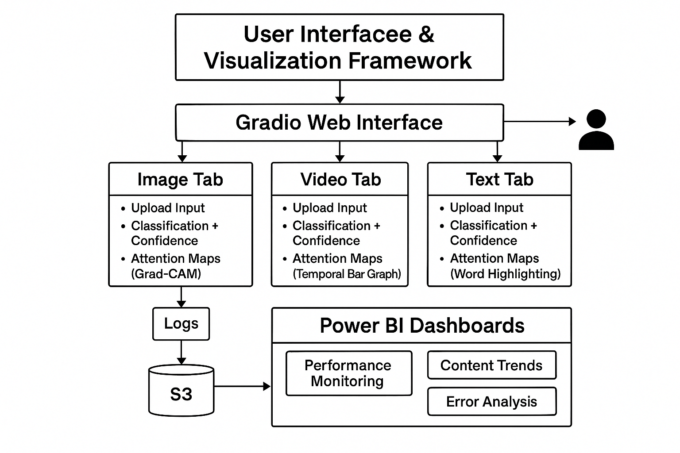

## 13. Results and Impact

The multi-modal deepfake detection system developed in this project was rigorously evaluated across its three core components—image, text, and video classification—yielding robust performance metrics and operational insights. These results not only validate the architectural choices made during system design but also demonstrate the potential for real-world application of AI-driven deepfake detection in domains such as journalism, digital forensics, and content moderation. In this section, we present a synthesis of the quantitative and qualitative results achieved by each modality-specific model, followed by a broader reflection on the system’s societal and technological impact.

From a classification performance standpoint, all three models achieved high accuracy and generalization on unseen test data. The Vision Transformer (ViT) image model reached a test accuracy of 97.1% with an F1 score of 0.96. These results were consistent across subcategories of generative sources, indicating the model’s ability to generalize across different synthesis techniques such as Stable Diffusion, Dreamlike, and GLIDE. The BERT-based text model similarly demonstrated strong results, with a test accuracy of 95.1% and an F1 score of 0.94. Importantly, it performed well across a range of linguistic tones and formats, from emotionally charged captions to neutral factual statements. The video model, combining ResNeXt and LSTM layers, achieved a test accuracy of 93.2% and an F1 score of 0.91, successfully distinguishing manipulated videos even in the presence of high-resolution rendering and realistic facial expressions.

These results were further reinforced through interpretability and robustness evaluations. Attention visualization techniques, such as Grad-CAM for images and saliency mapping for text and video, confirmed that the models were attending to semantically and visually relevant regions of the input. For example, image attention maps consistently highlighted unnatural edges, asymmetric facial lighting, or irregular textures, while the text model emphasized adjectives, sentiment-laden expressions, and imperative constructs typically found in disinformation content. The video model demonstrated sensitivity to subtle temporal inconsistencies in facial gestures or lip-syncing, particularly in synthetic sequences generated using Face2Face and NeuralTextures.

Beyond performance metrics, the integrated system showcased the feasibility of delivering real-time, multi-modal deepfake analysis through an accessible user interface. The Gradio application allowed end-users to receive instant feedback on images, videos, and captions, along with contextual explanations and visualizations. This real-time capacity is critical for use cases in newsrooms, social platforms, or public safety operations where rapid decision-making is required. Furthermore, the Power BI dashboards facilitated macro-level oversight of system performance, content trends, and classification outcomes, making the system usable not only by technical practitioners but also by policy-makers, analysts, and legal professionals.

The system’s impact also extends to its potential to inform regulatory discussions and public discourse around synthetic media. By providing a transparent and explainable detection platform, our project contributes to the growing body of responsible AI solutions aimed at mitigating the harms associated with generative technologies. The system’s modular design and cloud-compatible architecture position it well for deployment in large-scale environments, including media verification platforms, corporate brand protection services, and civic technology initiatives aimed at countering misinformation.

That said, it is important to acknowledge the limitations observed during evaluation. While the models performed strongly on benchmark datasets, their robustness in adversarial environments—where attackers may actively attempt to evade detection—remains to be fully validated. Additionally, the system is currently optimized for binary classification (“real” vs. “fake”) and does not yet support fine-grained attribution (e.g., identifying the specific generator used or the intent behind the manipulation). Furthermore, as generative models continue to evolve in sophistication, periodic retraining and dataset augmentation will be essential to maintain detection efficacy.

Despite these challenges, the system’s results demonstrate that a multi-modal, transformer-based architecture can effectively address the complex task of deepfake detection at scale. By unifying vision and language models into a coherent framework and coupling them with interpretable interfaces and dashboards, this project advances the frontier of applied AI in the fight against synthetic disinformation. The outcomes achieved provide a strong foundation for future research and deployment, and they serve as a proof-of-concept for how advanced machine learning systems can be responsibly leveraged to protect information integrity in the digital age.

In the next and final section, we discuss opportunities for improvement and outline future enhancements that could further strengthen the utility, scope, and resilience of the detection system.

## 14. Future Work

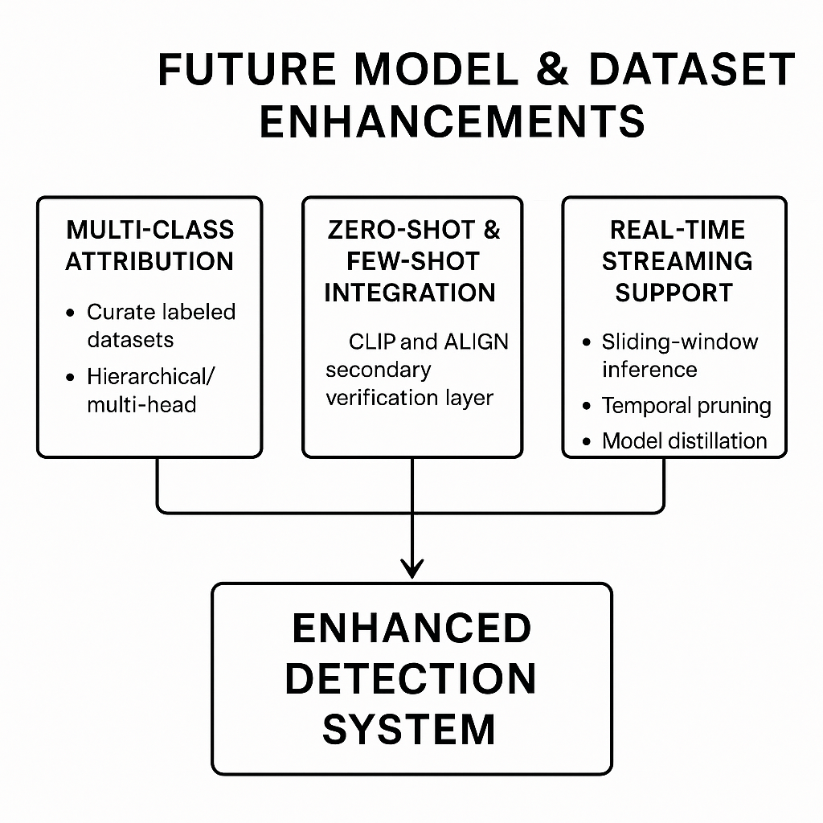

While the current implementation of our multi-modal deepfake detection system demonstrates strong performance and practical viability, the evolving nature of synthetic media demands continuous innovation and iterative refinement. Deepfake generation techniques are rapidly advancing, driven by breakthroughs in generative adversarial networks (GANs), diffusion models, and multimodal synthesis tools like OpenAI’s Sora and Meta’s Make-A-Video. As these generative models become more capable and accessible, the challenge of deepfake detection will become increasingly adversarial, requiring systems that are not only accurate but also adaptive, interpretable, and scalable. To that end, we outline several directions for future enhancement and expansion of our system across the domains of model architecture, dataset diversity, deployment strategy, and ethical governance.

A primary direction for future work is the extension of our detection system from binary classification to multi-class attribution. While our current models are designed to distinguish between “real” and “fake” content, they do not attempt to identify the source of the manipulation or the generative model responsible for it. Introducing fine-grained classification could significantly enhance the forensic value of the system, enabling stakeholders to trace manipulations to specific tools such as Stable Diffusion, StyleGAN, or FaceSwap. This would involve curating labeled datasets that isolate manipulation techniques and training models with hierarchical or multi-head output layers to support both binary and multi-class outputs. Such functionality could prove critical in legal or journalistic contexts where attribution is as important as detection.

In addition to attribution, we plan to explore the integration of zero-shot and few-shot learning models to improve detection of previously unseen manipulation types. Models like CLIP (Contrastive Language-Image Pre-training) and ALIGN (A Large-scale Image and Noisy-text embedding) offer the potential to encode cross-modal semantic relationships that generalize well across domains. By integrating zero-shot models as a secondary verification layer or ensemble component, the system could flag anomalous content even in the absence of explicit training examples. This approach would help address the arms race nature of deepfake detection, where new manipulation techniques emerge faster than labeled datasets can be created.

Another critical area of improvement is the handling of streaming and real-time content. Our current system is optimized for static inputs—individual images, video clips, and text captions. However, in real-world deployment scenarios, particularly on social platforms and surveillance systems, deepfakes may appear in live streams or time-sensitive news broadcasts. Extending the system to process continuous video feeds would require enhancements in data buffering, frame sampling, and computational optimization. Techniques such as sliding-window inference, temporal pruning, and model distillation could be explored to maintain high throughput while preserving accuracy.

On the infrastructure front, we intend to containerize the entire pipeline using Docker and orchestrate it through Kubernetes for scalable deployment across cloud environments. While our initial prototype was built using AWS S3, Glue, and Athena for storage and transformation, full production deployment would benefit from a microservices architecture that separates preprocessing, inference, and post-processing into independent services. This would allow for load balancing, modular updates, and fault-tolerant design, making the system suitable for enterprise or public-sector use.

Further research is also warranted in the area of interpretability and model auditing. Although we have implemented attention visualizations and saliency maps, deeper auditing frameworks such as LIME (Local Interpretable Model-Agnostic Explanations) or SHAP (SHapley Additive exPlanations) could provide more granular insights into model behavior. These tools would be especially useful in high-stakes applications, where explainability is not merely a feature but a requirement for accountability and trust. Additionally, integrating user feedback into the system—via thumbs-up/down votes or structured comments—could support semi-supervised learning, allowing the model to evolve in response to real-world usage patterns.

From an ethical and governance perspective, we also recognize the need for safeguards to prevent misuse of the system. As with any AI-driven tool, there is a risk that detection models themselves could be exploited or misinterpreted. To mitigate this, future deployments should include policy layers that limit model access based on user authentication, usage quotas, and content-type restrictions. Transparency reports detailing system performance, known limitations, and potential biases should be published regularly, especially if the tool is adopted by public or journalistic organizations.

Finally, we see significant potential in expanding the dataset to include more diverse demographic and linguistic contexts. Current datasets tend to overrepresent English-language captions and Western facial features, potentially limiting the generalizability of the model. A future version of the system should incorporate multilingual text detection, non-Western facial datasets, and region-specific generative tools to ensure fairness and inclusivity. Collaborations with international research institutions and fact-checking organizations could facilitate this effort by providing both technical resources and cultural insight.

In summary, while our current system provides a strong foundation for multi-modal deepfake detection, the field’s dynamic landscape necessitates a forward-looking roadmap. By incorporating zero-shot learning, real-time streaming support, cloud-native infrastructure, advanced interpretability, and ethical safeguards, future iterations of this system can continue to meet the rising demands of content authentication in a post-truth digital world.

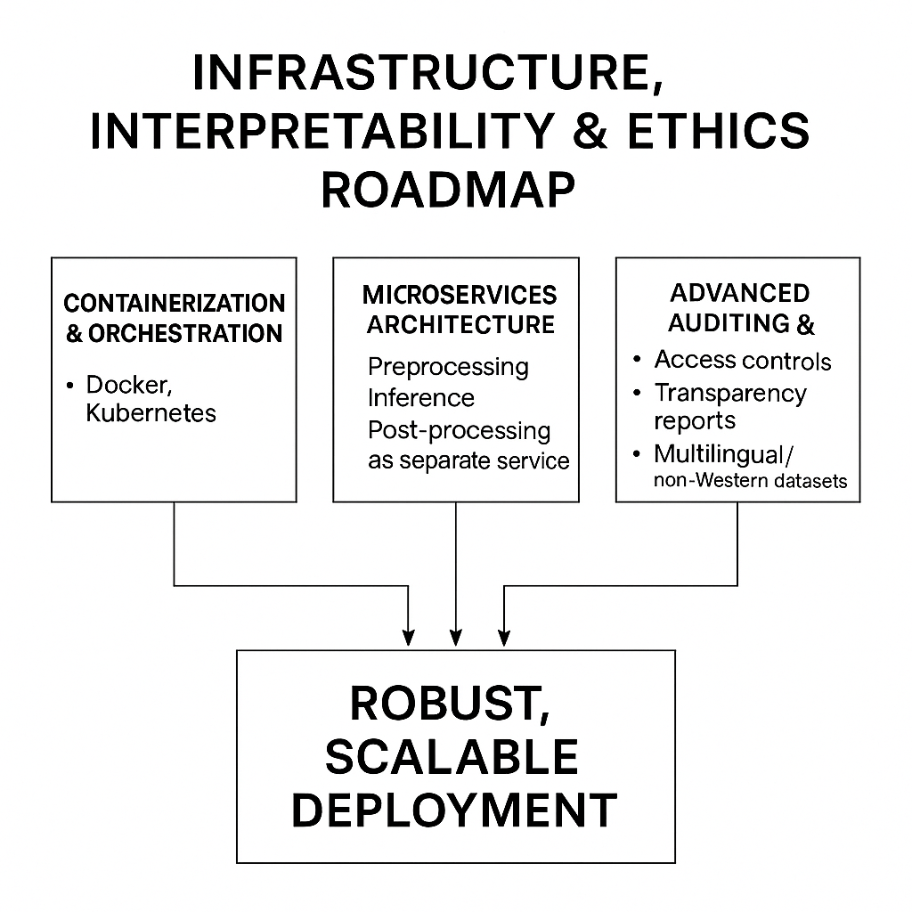

## 

## 1. Project Overview

## 

## Our project aimed to build a complete and robust AI-powered multi-modal deepfake detection system capable of processing and classifying inputs in the form of text, images, and videos. With the rise of generative models and sophisticated synthetic media, the lines between real and fake content have become increasingly blurred. As such, we wanted to engineer a system that could tackle disinformation across all three major forms: language, visual imagery, and motion.

## 

## To meet this challenge, we selected datasets that tightly integrate real and manipulated samples, especially focusing on captions and their corresponding visual content. Our image and video datasets included manipulations from multiple cutting-edge generative models such as Stable Diffusion, Dreamlike, GLIDE, and FaceForensics++, offering diversity in artifact style, composition, and manipulation technique. This ensured that the model could learn generalized features across generative types and avoid the rigidity often observed in overfit models.

## 

## Special attention was paid to the text classification component of our system. The dataset was composed of news-style captions, mimicking the writing style of modern disinformation campaigns. We deliberately fine-tuned our text detection models on these captions to teach the model how to spot linguistic cues of deception in content that would likely appear in real-world news articles or social posts.

## 

## While many previous projects in this field either limited their scope to image detection or relied on basic pre-trained models and fixed datasets, we decided to design the system from the ground up. This involved building a full ingestion and processing pipeline in the cloud, integrating AWS S3, AWS Glue, and Amazon Athena to manage dynamic data input and querying. By fusing predictions from multiple domain-specific models, including two separately fine-tuned BERT classifiers, our approach offered both interpretability and modular scalability.

## 

## The final system can handle multi-modal input and return confident predictions with real-time feedback. Our team goal was not just to detect fake content but to engineer a flexible, scalable architecture that could adapt to new manipulation styles, input formats, and real-world use cases.

## 

## 2. Role and Contributions

## 

## In this project, I contributed significantly across the data engineering and text model development pipelines. One of my earliest responsibilities was dataset discovery and sourcing. I curated benchmarked datasets appropriate for training image, video, and text classification models. I made sure the datasets incorporated various manipulation techniques, allowing the models to generalize beyond just one form of synthetic media.

## In addition to relying on built-in dataset integrity, I performed personalized data quality checks. These included validating schema consistency, ensuring all referenced files existed and matched metadata entries, and confirming the completeness of class labels across all partitions. In particular, I developed custom scripts to validate alignment between video clip directories and metadata records, a task that proved crucial when working with large-scale and distributed datasets.

## On the engineering side, I developed the initial ETL pipeline and was responsible for integrating it with AWS. I automated the uploading of our datasets into their corresponding S3 bucket directories. I also created event notifications in S3 that triggered crawler jobs whenever new data was added. This made our ingestion pipeline dynamic and responsive to updates.

## Using AWS Glue, I configured crawlers to target metadata files such as train1.csv, test1.csv, and video_metadata.csv. These crawlers automatically inferred schemas and registered them in the AWS Data Catalog. This enabled fast, SQL-style queries using Amazon Athena, which proved extremely helpful during feature engineering and exploratory data analysis.

## My most significant contribution was the development and fine-tuning of the two BERT-based text classifiers. The first model was trained on original captions sourced from real posts, while the second model was trained on AI-generated captions. Both models used the BERT base architecture and were fine-tuned on inputs truncated to 128 tokens. The models were trained on a GPU environment in Colab using a batch size of 16 and the AdamW optimizer. I handled everything from tokenization and preprocessing to optimization and evaluation.

## These models were later fused at the probability level using weighted averaging to produce the final decision. The fusion logic leveraged the strengths of both models, compensating for their individual weaknesses. I also helped design the final model fusion diagram and contributed to the architecture visuals in the final paper.

## 

## 3. Learnings and Skills Gained

## 

## This project taught me more than any previous effort about the real-world application of AI systems. From a technical standpoint, I gained deep insight into transformer fine-tuning and the internal architecture of BERT. I now understand how BERT leverages its context understanding layer and classification head to make semantic-level predictions. I also became proficient in padding, truncation, and attention mask management—critical steps in pre-processing for BERT.

## I learned how to troubleshoot and fine-tune model hyperparameters to reduce overfitting and maximize test accuracy. Equally important, I got hands-on exposure to AWS tools like Glue, Athena, and S3, including crawler configuration, metadata schema inference, and query optimization.

## My understanding of video data pipelines improved as well. I explored how video frames are extracted, tokenized, and passed through patch-based architectures like Vision Transformers (ViT). Although I didn’t lead the image or video modeling phases, collaborating closely with those who did helped expand my understanding of temporal data processing.

## Another big takeaway was the reality of deployment complexity. Our original plan was to containerize the app and deploy it on an EC2 instance using Docker. However, we encountered persistent issues with image layer compatibility and runtime environment mismatches. After several unsuccessful attempts to resolve these conflicts, we pivoted to deploying our application via Gradio, which proved more efficient and less error-prone in our timeline.

## On the soft skills side, I learned how to communicate technical updates under tight deadlines and collaborate iteratively. Managing changes in the dataset and model outputs while keeping the documentation aligned required discipline and clear communication. Debugging under pressure, especially in GPU-restricted environments like Colab, also pushed me to optimize my workflows for both performance and reliability.

## 

## 4. Business Impact and Future Prospects

## The societal relevance of our project cannot be overstated. Deepfakes are no longer confined to academic novelty—they are being weaponized to influence public opinion, manipulate markets, and spread disinformation at scale. Our system is directly applicable to real-world domains such as media forensics, journalism, and social platform moderation. Tools like ours could serve as the backend validation layer for image or video uploads, flagging suspicious content in real-time.

## If we had more time, I would extend the system to support multi-language text detection and audio modality classification. Incorporating zero-shot or few-shot learning capabilities would also allow the model to generalize to unseen manipulation techniques. Additionally, I would consider integrating the detection system with retrieval-augmented generation (RAG) to fact-check claims in real time.

## This project has directly prepared me for AI-focused internships and research. It solidified my ability to work across multiple ML stacks—from raw data ingestion to cloud deployment and model interpretability. It also deepened my appreciation for the ethical responsibilities involved in building systems that influence public trust. Looking forward, I hope to expand this work into a research paper or even evolve it into a tool that can be adopted by journalists and fact-checkers worldwide.

## 15. References

[1] J. Devlin, M.-W. Chang, K. Lee, and K. Toutanova, “BERT: Pre-training of Deep Bidirectional Transformers for Language Understanding,” arXiv preprint arXiv:1810.04805, 2018.

[2] A. Dosovitskiy, et al., “An Image is Worth 16x16 Words: Transformers for Image Recognition at Scale,” arXiv preprint arXiv:2010.11929, 2020.

[3] K. He, X. Zhang, S. Ren, and J. Sun, “Deep Residual Learning for Image Recognition,” in *Proc. IEEE Conf. Comput. Vis. Pattern Recognit. (CVPR)*, 2016, pp. 770–778.

[4] A. Rössler, D. Cozzolino, L. Verdoliva, C. Riess, J. Thies, and M. Nießner, “FaceForensics++: Learning to Detect Manipulated Facial Images,” arXiv preprint arXiv:1901.08971, 2019.

[5] A. Radford et al., “Learning Transferable Visual Models from Natural Language Supervision,” arXiv preprint arXiv:2103.00020, 2021.

[6] H. Khalid, S. Khalifa, F. Ismail, and T. A. Eisa, “Fake or Real? A Fast and Effective Deep Learning Approach for Fake News Detection,” arXiv preprint arXiv:1911.03854, 2019.

[7] X. Zhang, X. Zhou, M. Lin, and J. Sun, “ShuffleNet: An Extremely Efficient Convolutional Neural Network for Mobile Devices,” arXiv preprint arXiv:1707.01083, 2017.

[8] R. R. Selvaraju et al., “Grad-CAM: Visual Explanations from Deep Networks via Gradient-Based Localization,” in *Proc. IEEE Int. Conf. Comput. Vis. (ICCV)*, 2017, pp. 618–626.

[9] M. T. Ribeiro, S. Singh, and C. Guestrin, “Why Should I Trust You?: Explaining the Predictions of Any Classifier,” in *Proc. 22nd ACM SIGKDD Int. Conf. Knowledge Discovery and Data Mining*, 2016, pp. 1135–1144.

[10] S. M. Lundberg and S.-I. Lee, “A Unified Approach to Interpreting Model Predictions,” *Advances in Neural Information Processing Systems*, vol. 30, pp. 4765–4774, 2017.

[11] Z. Liu et al., “DeepFakeNews: A Multi-Modal Benchmark Dataset for Deepfake Detection,” *Zenodo*, 2023. [Online]. Available: https://zenodo.org/record/11186584

[12] OpenAI, “GPT-4 Technical Report,” OpenAI, Mar. 2023. [Online]. Available: https://openai.com/research/gpt-4

[13] A. Al-Nasseri, H. Alenezi, and H. Alzahrani, “Deepfake Detection Using Convolutional Neural Networks,” *Int. J. Adv. Comput. Sci. Appl. (IJACSA)*, vol. 13, no. 1, pp. 456–462, 2022.

[14] B. Dolhansky et al., “The Deepfake Detection Challenge (DFDC) Preview Dataset,” arXiv preprint arXiv:1910.08854, 2020.

[15] P. Korshunov and S. Marcel, “Deepfakes: A New Threat to Face Recognition? Assessment and Detection,” arXiv preprint arXiv:1812.08685, 2018.

[16] D. Montserrat et al., “Deepfakes Detection with Automatic Visual Features,” in *Proc. IEEE Int. Conf. Image Processing (ICIP)*, 2020.

[17] S. Guera and E. J. Delp, “Deepfake Video Detection Using Recurrent Neural Networks,” in *Proc. 15th IEEE Int. Conf. Adv. Video and Signal Based Surveillance (AVSS)*, 2018.

[18] H. Chugh, A. Jain, H. H. S. Ip, and A. Kumar, “Not Made for Each Other: Audio-Visual Disparities in Deepfake Videos,” in *IEEE Winter Conf. Appl. Comput. Vision (WACV)*, 2020.

[19] Y. Li and S. Lyu, “Exposing DeepFake Videos by Detecting Face Warping Artifacts,” in *Proc. IEEE Conf. Comput. Vis. Pattern Recognit. Workshops (CVPRW)*, 2019.

[20] L. Verdoliva, “Media Forensics and DeepFakes: An Overview,” *IEEE J. Sel. Top. Signal Process.*, vol. 14, no. 5, pp. 910–932, Aug. 2020.